Western Australia

An Indo-Pacific space hub

Space Sector Overview

Ongoing 2026

Contents
1. Overview 2
2. Capabilities 3
3. Current focus areas 4
3.1. Space mission operations and exploration 4
3.2. Space ground infrastructure 5
3.2.1 Communication ground stations 5
3.2.2 Space tracking telescopes and radars 6
3.2.3 Space launch and returns 7
3.3. Space systems and hardware 8
3.4. Space enabled services and data analytics 9
3.4.1 Space enabled services 9
3.4.2 Data analytics 10
3.5. Technology transfer 11
3.6. Research, training and education 12
4. Related capabilities 13
4.1. Defence Science 13
4.2. Radio astronomy infrastructure 13
4.3. SME support and training 13

Overview
Western Australia has played a significant role in the global space industry for over 60 years, supporting international space agencies, the commercial space sector and major space missions.
Home to clear skies, vast land expanses, and ideal geographic latitude and longitude for space activities. Western Australia is involved in a range of space domains, hosts significant space infrastructure for both civil and defence applications and is home to more than 140 international and Australian organisations operating space and space related services.
Leveraging Western Australia’s significant space infrastructure, leading space science and research, vibrant space ecosystem, Western Australia has become a major Indo-Pacific space hub.
Significant areas of activity and capability include space mission operations; ground-based satellite and deep space communications; space situational awareness; data processing and analysis; satellite design and build; and launch.
Western Australia is also home to five universities and various research institutions with established expertise in the space industry and related sectors. The Western Australian workforce is highly skilled and diverse, with a pipeline of skilled workers in space and space related fields.
Western Australian organisations also have strong collaborations with international space and defence companies and international space agencies including NASA, European Space Agency (ESA), Indian Space Research Organisation, Japan Aerospace Exploration Agency (JAXA) and Malaysian Space Agency.
Building on these strengths and utilising the State’s significant and expanding space infrastructure, capabilities, and geographic advantage for the global coverage of space assets, Western Australia will continue to increase activities in providing critical space mission and remote operation services to international space agencies and private space companies.
With a diverse and strong economy, Western Australia also has a significant market for space technology and space data within its mining, oil and gas, agriculture, defence, energy, and maritime industry sectors.
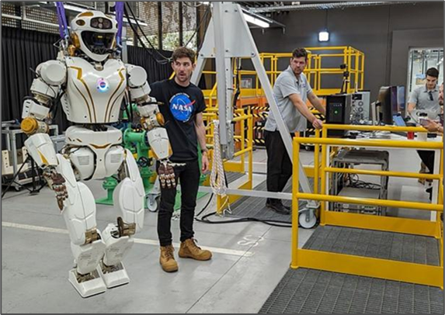
Image: NASA Valkyrie testing at Woodside Energy’s robotics lab, Perth, 2023.

Capabilities
Western Australia has significant capabilities in the space industry sector including the following advantages and opportunities:
- Southern Hemisphere location and longitude ideal for launch and returns, space tracking and global coverage of space assets.
- Ideal environmental conditions: geologically stable with clear skies, large arid areas with minimal radio interference and radio-quiet zones.
- Partnerships and extensive activity with international space agencies and private space companies.
- Substantial capabilities in space mission operations; space communications; space tracking; space systems and hardware; satellite design and build, space enabled services and data analytics; technology transfer; and astronomy and planetary research.
- Strong economy with a significant demand for space data, satellite services, and technology transfer with Western Australia’s key industries (mining, energy, agriculture, defence and maritime).
- Vibrant R&D ecosystem: home to five universities and various research institutions with established expertise in space sciences and related fields.
- Diverse and highly skilled workforce, with a pipeline of skilled workers in space and space-related fields.
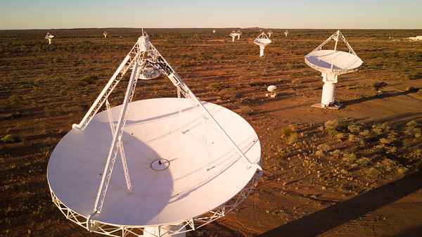
Image: CSIRO’s Australian Square Kilometre Array Pathfinder telescope in Western Australia.

Current focus areas
Space mission operations and exploration  Western Australia is the world-leader in remote mission operations for terrestrial industries, with significant activity in the State at the intersection of space and terrestrial mission operations.  The State also has significant capability in space exploration; ranging from the use of optical and radio telescopes for astronomy, to the physical exploration of space using spacecraft. | 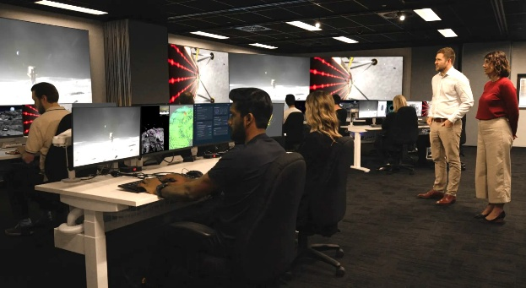  Image: SpAARC, Perth
Key infrastructure, research and activities include:
- Fugro’s Australian Space Automation, AI and Robotics Control Complex (SpAARC) in Perth is a world-class facility for space missions and remote operations in harsh environments such as subsea and space. SpAARC supports a number of upcoming international lunar missions.
- CSIRO provides operational support and facility management for ESA’s New Norcia facility and Inyarrimanha Ilgari Bundara, the Murchison Radio-astronomy Observatory.
- The Perth headquartered Australian Remote Operations for Space and Earth (AROSE) entity is a not-for-profit, industry-led consortium that aims to position Australia as the trusted leader of remote operations for terrestrial and space sectors. AROSE members include research organisations, terrestrial and space companies.
- Woodside Energy Group partners with NASA to explore automation, remote operation and the robot-human interface and has a NASA Valkyrie humanoid system for testing.
- Companies such as Harvest Technology Group provide cutting-edge remote operations connectivity utilising ultra-low bandwidth satellite communications.
- Companies such as CADwalk and Sentient provide designs, VR and test labs for space and terrestrial mission control centres and lunar habitats.
- Western Australia also has world-class astronomy capability at CSIRO, Curtin University and The University of Western Australia (UWA); particularly through their involvement in establishing the Square Kilometre Array (SKA) Observatory the world's biggest radio-telescope being constructed in the State’s Mid West region and South Africa.
- Curtin University, Edith Cowan University (ECU) and UWA also have significant experience in supporting ESA, JAXA and NASA space exploration missions. A number of Western Australian organisations including Curtin University and ECU are also designing hardware for planetary exploration.
- AROSE, Curtin University and ECU are partners in the LifeSprings Mars mission, which aims to collect presumed Martian hot spring deposits to investigate for signs of past life.

- Space ground infrastructure  3.2.1 Communication ground stations  Western Australia, with its clear skies and large arid areas with minimal radio interference is particularly well placed for space communication. | 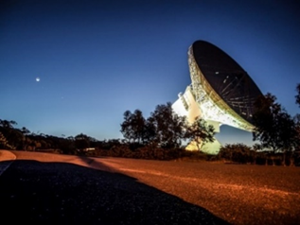  Image: ESA DS-1 Tracking Station in New Norcia.
Current space communication infrastructure and activity in Western Australia:
- ESA’s New Norcia Deep Space Ground Station is part of ESA's global tracking station network. The site contains two of only four active antennae worldwide in ESA’s deep space tracking network. CSIRO manages the New Norcia site.
- Mingenew Space Precinct is sited within a 300 km radio frequency Earth Station Protection Zone established by the Australian Communications and Media Authority to support the development of space communications facilities in the area. The area is also a no-fly zone to allow laser communication and ranging activities. Current operators in the Precinct include:
  - Australian Maritime Safety Authority - satellite tracking station for the regional detection and location of emergency distress beacon activations
  - Capricorn Space which also hosts ATLAS Space Operations, Infostellar, KSat, Leaf Space Srl and Planet.
  - Geosciences Australia – operates NASA’s Yarragadee Geodetic Observatory
  - SSC Space - Western Australia Space Center which hosts space communication infrastructure including optical communications.
- Perth International Telecommunications Centre provides ground station hosting and ground station as-a-service options.
- Starsite provides ground station-hosting facilities in the Geraldton region and is hosting a KSAT lunar ground station.
- TeraNet is a commercial three-node optical communications ground station network built to support satellite communications and international space missions. TeraNet utilises UWA’s world-leading atmospheric turbulence mitigation optical laser communication technology and also has PNT and SSA capability.
- The Australian Defence Satellite Communications Station (ADSCS), located at Kojarena is part of the US signals intelligence and analysis network ECHELON.
- Companies such as APD Global construct satellite downlink stations.
- Companies such as Bend-tech, GSM, Stantec Australia, Stratham Engineering Australia, TIAM Solutions, Flow Consulting and Rossi Mechanical support the establishment of ground infrastructure including satellite dish construction, assembly, site establishment and maintenance.

 | 3.2.2 Space tracking telescopes and radars  Western Australia hosts a variety of space infrastructure providing space situational awareness (SSA). Due to our ideal Southern Hemisphere geography, Western Australia also has international collaborations and research focused on technologies to detect, track and monitor objects in space. |  | 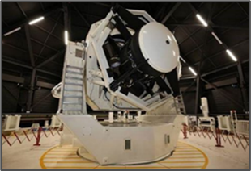  Image: US-Aust. Space Surveillance Telescope.
Key infrastructure and activities include:
- World-leading joint US-Australian Space Surveillance Telescope, C-Band Space Surveillance Radar System (operated by Raytheon Australia) and the Deep Space Advanced Radar Capability located at the Naval Communications Station Harold E. Holt in Exmouth.
- LeoLabs’ West Australian Space Radar near Bunbury is a part of LeoLabs’ global network of ground-based, phased array radars producing high-resolution data on objects in LEO.
- EOS Space Systems, in partnership with Lockheed Martin, has established a facility for Low Earth Orbit and cis-lunar optical space surveillance at Learmonth.
- Curtin University’s FireOpal is a world-class optical space tracking system developed in partnership with Lockheed Martin.
- Royal Australian Air Force Jindalee Operational Radar Network near Laverton is a state-of-the-art early warning radar system that provides wide area surveillance.
- The MWA telescope at the MRO Observatory has undertaken passive radar detection of space debris in Earth orbit. Curtin University is working with the Defence Science and Technology Group and the US Air Force on a number of projects to expand these capabilities.
- Learmonth Solar Observatory, jointly operated by Bureau of Meteorology - Space Weather Services and US Air Force is part of the world-wide Global Oscillation Network Group network.
- NASA/Geoscience Australia’s MOBLAS 5 Satellite Laser Ranging Station is sited at the MSP.
- SSC Space has installed a SSA facility at the MSP which has been operational since 2022.
- UWA’s Space Surveillance Hub is located 70 kilometres north of Perth and hosts the following SSA ground infrastructure:
  - UWA Zadko Telescope for SSA, astronomy, gravitational wave research and tracking launch
  - French based Ariane Group - two SSA optical telescopes
  - US based Numerica - Slingshot Aerospace SSA optical telescope
  - Polish Space Agency SSA optical telescope
  - JAXA optical telescope
  - United States Air Force Academy - Falcon telescope for SSA research and STEM.
- ExoAnalytic Solutions has SSA telescope sites situated near Perth and Geraldton.
- Thoth/COMSPOC is establishing a deep space SSA facility near Carnarvon and COMSPOC has established an SSA ground station at Perth Observatory.
3.2.3 Space launch and returns  Western Australia has significant advantages and opportunities for the establishment of new launch facilities and supporting the return of rockets and spacecraft. |  |  | 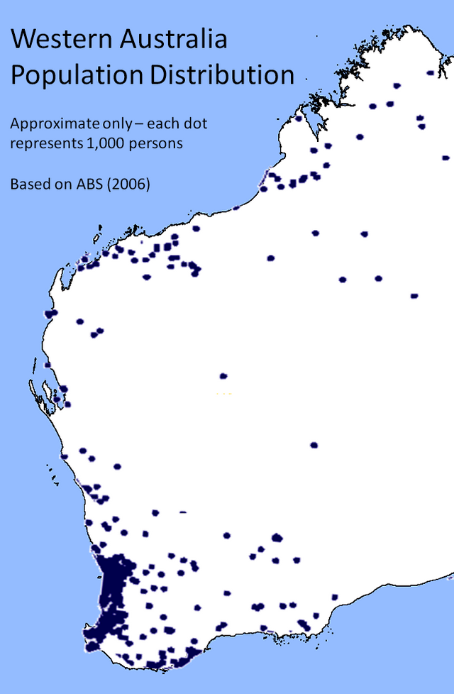 |  | 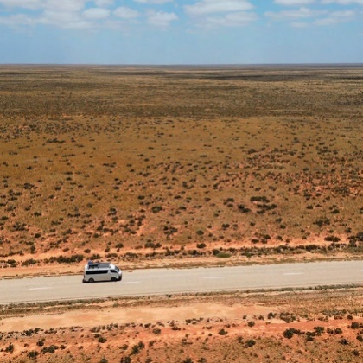
 |  |  | Image: Map of Western Australia’s population density and open expanses along the south coast.
Mainland Western Australia is the largest State in Australia and spans latitudes from -14ºS to -35ºS. Christmas Island (-10ºN) and Cocos (Keeling) Islands (-12ºN), south of Java and Sumatra are also governed by the Western Australian Government. Western Australia has a land area of 2,527,013 square kilometres and is very sparsely populated (3 million people).
Thus, there is an opportunity for launch to equatorial, polar and sun synchronous orbits from Western Australia. Interest in establishing launch capabilities in the State has increased significantly in recent years and a number of national and international organisations are working with the Western Australian Government to establish launch sites. Western Australia has significant experience in establishing major facilities in remote areas through its massive resources industry. There is also significant opportunity to decarbonise launch activities through the use of renewable power at facilities and green fuels for propulsion.
Current companies operating or establishing launch facilities include:
- OneTide is progressing its maritime and terrestrial rocket launch systems.
- Space Angel is establishing the Australis network of commercial green spaceports on Western Australia’s south coast and Christmas Island. Space Angel is also developing Forrest Airport for space launch activities.
- SpinLaunch is also exploring the establishment of a spaceport on Western Australia’s south coast.
- WA Spaceport is developing a launch facility near Albany.
A number of the companies progressing launch facilities mentioned above also have plans to conduct space returns as part of their operations.
The Western Australian Government is undertaking a study to identify the best sites for launch and returns activities.
In addition:
- UWA’s ISC is undertaking research focused on developing rocket propellants using catalysts and in-situ space resources.
- HyperPower Technologies is developing electric motors for rocketry.
- Darco Industries provides insulation and safety materials for launch infrastructure.
 |  | - Space systems and hardware  Western Australia has emerging capabilities in the design, manufacturing and operation of space systems including satellites, satellite payloads and sensors. This includes: |  | 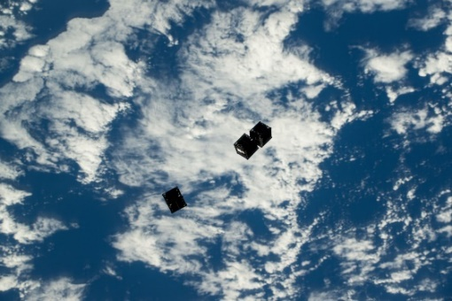  Image (JAXA): Curtin University Binar 2, 3 and 4 released from the International Space Station.
- Curtin University's Space Science and Technology Centre has developed the Binar CubeSat, the first spacecraft to be fully designed and manufactured in Australia. Using cost-effective manufacturing, it provides an accessible sovereign platform, enabling easy access to space. The satellite can be used for remote sensing, imaging, communications and defence, and represents a lower barrier of entry for start-ups to develop and test their technology in space. The first satellite was launched into space in August 2021 with a further three in August 2024.
- Perth based Australian satellite company LC60 AI has exclusive rights for numerous Earth observation satellites over Australia, Asia Pacific and Middle East. This capability supports LC60 AI's expansion across the Southeast Asia region as it scales up its product applications. LC60 AI is also developing a (SWIRSAT) constellation of satellites to measure carbon emissions. The first two SWIRSAT satellites are scheduled to be launched into LEO in early 2027.
- Australian National Fabrication Facility Western Australian node, based at UWA, runs a complete, vertically integrated facility, from materials growth, through to device design, fabrication and testing. The node incorporates UWA’s Microelectronics Research Group which is one of Australia's largest and most respected semiconductor electronics research groups and is leading the world in the innovative combination of micro-electromechanical system with infrared (IR) sensor technologies for fourth generation IR systems suitable for satellite use.
- ECU is increasing its satellite and space exploration capability and hosts LC60 AI’s Space Integration Facility.
- Companies such as AVI, Blacktree Technology, and Bushcomm, design, engineer and manufacture mission critical communication systems and Adarsh, ATMWA, Element Engineering Australia, Marsen Energy manufacture satellite hardware.
- Companies such as Calytrix Technologies provide training solutions for satellite operations. LEAP provides simulation services for development of space systems. Petritek provides specialised spacecraft transportation services and EzziVision provides products for satellite testing.

- Space enabled services and data analytics  3.4.1 Space enabled services  Western Australia has extensive capability in using satellites for EO, communications and GPS for precise positioning in agriculture and mining, disaster management, urban planning, and scientific research. | 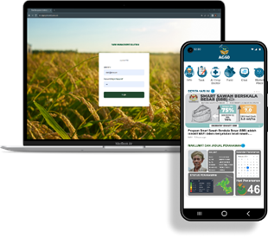  Image: LC60AI’s ‘AG60’ platform, providing analytics to 125,000 Malaysian Rice Farmers
- LC60 AI is focused on providing end-to-end EO products and services, from developing a constellation of satellites and payloads to collect multispectral EO data, through to analysis and fusing its data with other data types to provide products and insights for customers. LC60 AI has several partnerships and collaborations across Australia and Asia. The Western Australian Government has also invested in LC60 to advance the State’s commercial EO and satellite assembly capabilities.
- Through its Western Australian office, CSIRO, manages Australia’s share in NovaSAR-1, an EO satellite capable of observing through cloud, smoke and at night. Australian researchers and industry can request to task the satellite and access the image archive free of charge via CSIRO’s NovaSAR-1 data hub.
- CSIRO manages a network of ground-based satellite calibration and validation sites across Australia used by international space agencies to ensure the accuracy of data collected by satellites. This includes the Pinnacles Desert site, ~200 km north of Perth. This infrastructure network supports domestic and international operators to calibrate their satellites and verify the data they collect. This is vital to ensuring the accuracy of data collected by satellites.
- ESA has established a Biomass Calibration Transponder at its New Norcia facility for calibration of its synthetic aperture radar satellite measuring forest biomass.
- Landgate, the Western Australian Land Information Authority, is at the leading-edge of research and development in remote sensing and its applications, providing a full range of remote sensing services: from direct acquisition of satellite data, to processing of data and then delivering that data to government and business via their products and services.
- Omnidea’s partner company GEOSAT, owns and operates two satellites, GEOSAT 1 and GEOSAT 2. Using their high-quality imagery and analytics expertise, GEOSAT is focused on providing insights to help customers across multiple industries make better-informed decisions.
- Other key WA space data analytics and EO organisations include Ecocene, Fastwave, FrontierSI, Gaia Resources, Geospatial Intelligence, In Situ Marine Optics, Maptaskr, NGIS, QLSpace and Soar.
- UWA has developed world-leading optical satellite communications technology (see above).
- Curtin University’s GNSS Satellite Positioning and Navigation Group develops theory, models, and methods to provide the high accuracy and high-integrity requirements for future GNSSs.

3.4.2 Data analytics  Western Australia has significant computing infrastructure and capability in data science, analytics and cybersecurity. Key Western Australian infrastructure and activities include: | 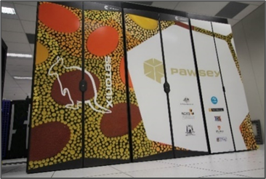  Image: Pawsey’s Setonix supercomputer.
- The Perth-based Australian Space Data Analysis Facility (ASDAF) has been established to enhance Australian SMEs and researchers’ ability to use space data, particularly EO data to provide solutions and services to terrestrial industry.
- The Perth-based Pawsey Supercomputing Research Centre (Pawsey) is the lead Tier 1 supercomputing research facility in Australia and hosts the most powerful research supercomputer in the Southern Hemisphere. Pawsey provides a range of supercomputing, data storage and data visualisation services, as well as key expertise, training and support. Pawsey has also installed the world’s first market-ready diamond quantum accelerator (quantum computer) which operates without the requirement of near absolute zero temperature or complex laser systems.
- Perth-based DUG Technology is at the forefront of high-performance computing (HPC) and currently operates the most powerful commercial supercomputer in the Southern Hemisphere. DUG is building the world’s first carbon-free HPC campus powered by renewable energy in Geraldton. The first data hall will have a capacity of 400 petaflops, with plans for expansion to multi-exaflop scale. DUG has established partnerships with Curtin University in the areas of radio astronomy and astrophysics and the development of algorithms that can detect and monitor space junk and satellites in Earth orbit. DUG is also working with LC60 on HPC data analytics solutions for EO data.
- WA Data Science Innovation Hub provides access to specialised data science capabilities in universities and trained graduates, upskilling programs for industry, the translation of data science capabilities from the resources sector to emerging sectors.
- ECU is a world-leader in cyber security research and cyber security education and is recognised by the Australian Government as an Academic Centre of Cyber Security Excellence. ECU is home to the Centre for Securing Digital Futures and the Cyberwest Hub. ECU also hosts the largest university Security Operations Centre in the Southern Hemisphere that provides students real world training in monitoring, detecting and responding to cyber security threats.
- Curtin University and Australian cyber security company CyberCX have teamed up to build Nebula, a sovereign cloud platform to host sensitive research. Nebula is designed in cooperation with universities, industries and government to make sure their diverse requirements are met.

- Technology transfer  Western Australia is at the forefront of technology transfer between terrestrial and space industry sectors. Key examples include: | 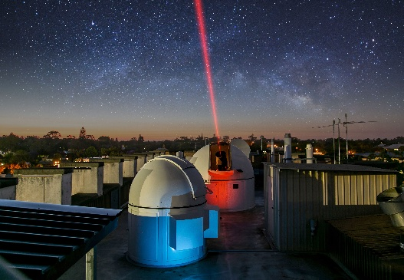  Image: TeraNet optical ground station, UWA.
- Ablano is a nano-technology company that has developed a process to convert commercially available materials into advanced nano-materials. One product under development is a nano-based lubricant suitable for use in extreme conditions such as space. Ablano’s nano-materials also have attributes suitable for radiation shielding.
- The AROSE consortium transfers terrestrial remote operations, AI, automation and robotics capability to space.
- Curtin University and UWA have spun out radio astronomy technology developed for the SKA project for passive SSA and optical satellite communications.
- Fugro-SpAARC is transferring its marine remote operations expertise to space to support Intuitive Machines lunar program.
- OffWorld has pivoted its robot swarm technology from off-Earth mining to terrestrial mining, processing, manufacturing, and construction.
- Transparent Earth Geophysics (TEG)/Advanced Navigation have transferred their capability in terrestrial gravimetry (used for resources prospecting) to develop a state-of-the-art, autonomous lunar navigation system to be tested on the Moon by Intuitive Machines.
- Woodside Energy Group has partnered with NASA to explore automation, remote operation and the robot-human interface and is testing NASA’s Valkyrie humanoid system in the terrestrial resources sector.
The Western Australian Government is keen to accelerate technology transfer between space and terrestrial industry sectors. As such, the Government supported the establishment of the Indo-Pacific Space and Earth Conference that promotes uptake of space-enabled and cross-sector technologies and promotes technology transfer opportunities globally to benefit all industries.

- Research, training and education  Western Australia has significant capability in space research, training and education including: | 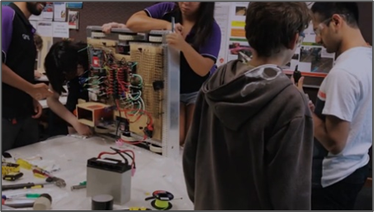  Image: Curtin University robotics laboratory.
- CSIRO in Western Australia undertakes research in satellite design and control, EO, signal processing and radio astronomy. CSIRO has 100 personnel working in space and space-related projects in the State.
- Curtin University’s Space Science and Technology Centre (SSTC) is home to the largest planetary research group in the Southern Hemisphere. Key strengths include SSA, space engineering and machine learning in planetary geology. Curtin University’s Remote Sensing and Satellite Research Group undertakes research related to calibration and validation of satellite remote sensing observations. Curtin University’s GNSS Satellite Positioning and Navigation Group develops future GNSSs and novel satellite constellation navigation systems. Curtin University annually graduates dozens of science and engineering students in spacecraft design, space missions, EO and GNSS. SSTC also runs the BinarX outreach program for high school students to design and prototype satellite payloads.
- ECU is currently establishing new space research and training capability with an emphasis on space exploration, spacecraft design and build, communications and SSA.
- UWA’s International Space Centre (ISC) is a multi-disciplinary team that includes more than 12 research nodes and 150 researchers. ISC specialises in (space) optical communications, SSA, batteries, propulsion systems, health, agriculture, engineering, IT, and social studies. UWA graduates dozens of science and engineering students trained in these space sectors. UWA also runs a Space Boot Camp for Year 9 and 10 students. UWA also hosts the Defence and Security Institute with expertise in space, AI, automation and quantum technologies.
- The International Centre for Radio Astronomy Research (ICRAR) is a joint venture between Curtin University and UWA. ICRAR is an internationally renowned, multi-disciplinary research centre which has played an integral role in the development of the Square Kilometre Array (SKA) project and translation of radio astronomy technologies and expertise to other industry sectors. Curtin University’s Curtin Institute of Radio Astronomy, a world-class radio astronomy institute supports ICRAR and a number of international projects. Both groups undertake training of dozens of students annually.
- The Western Australian Government also supports the Western Australian Space Science Education Centre (WASSEC). WASSEC provides students with a simulated Mars surface, specialist technology and science facilities, and mission control and cybersecurity experience.
- STEM and space outreach programs, with Western Australian Government support, are also undertaken by AROSE, Gravity Discovery Centre, ICRAR, Pawsey, Perth Observatory, Scitech and the Western Australian Museum.

Related capabilities

Defence Science
The Defence Science Centre (DSC) is the Western Australian contribution to the Australian Defence Science and Universities Network. This network supports the national Defence enterprise through collaboration between state university researchers, industry, Defence Science and Technology Group, and Defence end-users. This facilitates the engagement of Australia's best research and development capabilities to apply their research to real-world Defence needs and challenges. The DSC also supports the commercialisation of defence-related research.

Radio astronomy infrastructure
CSIRO’s Inyarrimanha Ilgari Bundara, Murchison Radio-astronomy Observatory (MRO) is a world-class site for radio astronomy and hosts the Australian SKA Pathfinder radio telescope, Murchison Widefield Array and will host the SKA-Low Telescope which is currently under construction.
Western Australia will also host the SKA-associated Australian Science Operations Centre, Australian Science Processing Centre, Australian SKA Regional Centre, Murchison Observatory Support Facility and Engineering Operations Centre.

SME support and training
Perth hosts a number of Start-up and SME innovation hubs that support the space sector including the Centre for Entrepreneurial Research and Innovation, CORE Innovation Hub, ERDi Testlab, Innovation Central Perth, Perth Landing Pad, Spacecubed and WA Data Science Innovation Hub.

Contact Details:
This document was prepared by the Department of Energy and Economic Diversification to provide an overview of Western Australia’s space capability and activities.

Website:https://www.wa.gov.au/organisation/department-of-energy-and-economic-diversification/western-australia-space-industry

Contact e-mail: space@deed.wa.gov.au

