Quick Reference Guide
This QRG aligns with the Project Management Framework

Ready Contracts
Contract Dashboard

This guide provides instructions on how to manage the Contract Dashboard. The Contract Dashboard provides a single dashboard view of the status of an individual contract including:

Key contract information

Highlighting exceptions / items that need to be addressed.

You can choose the items to display on your Contract Dashboard as well as its layout.
Contents
Accessing the Contract Dashboard 1
Showing or hiding the Contract List while viewing the Contract Dashboard 2
Adding Widgets to your Contract Dashboard 4
Removing widgets from the Contract Dashboard 5
Changing the Widget Settings 6
Changing the layout of your Contract Dashboard 6

Accessing the Contract Dashboard
To access the Contract Dashboard, you must first select a contract from either the Contract List or your Recent Contract widget and then selecting the Contracts > Contract Dashboard screen from the menu.
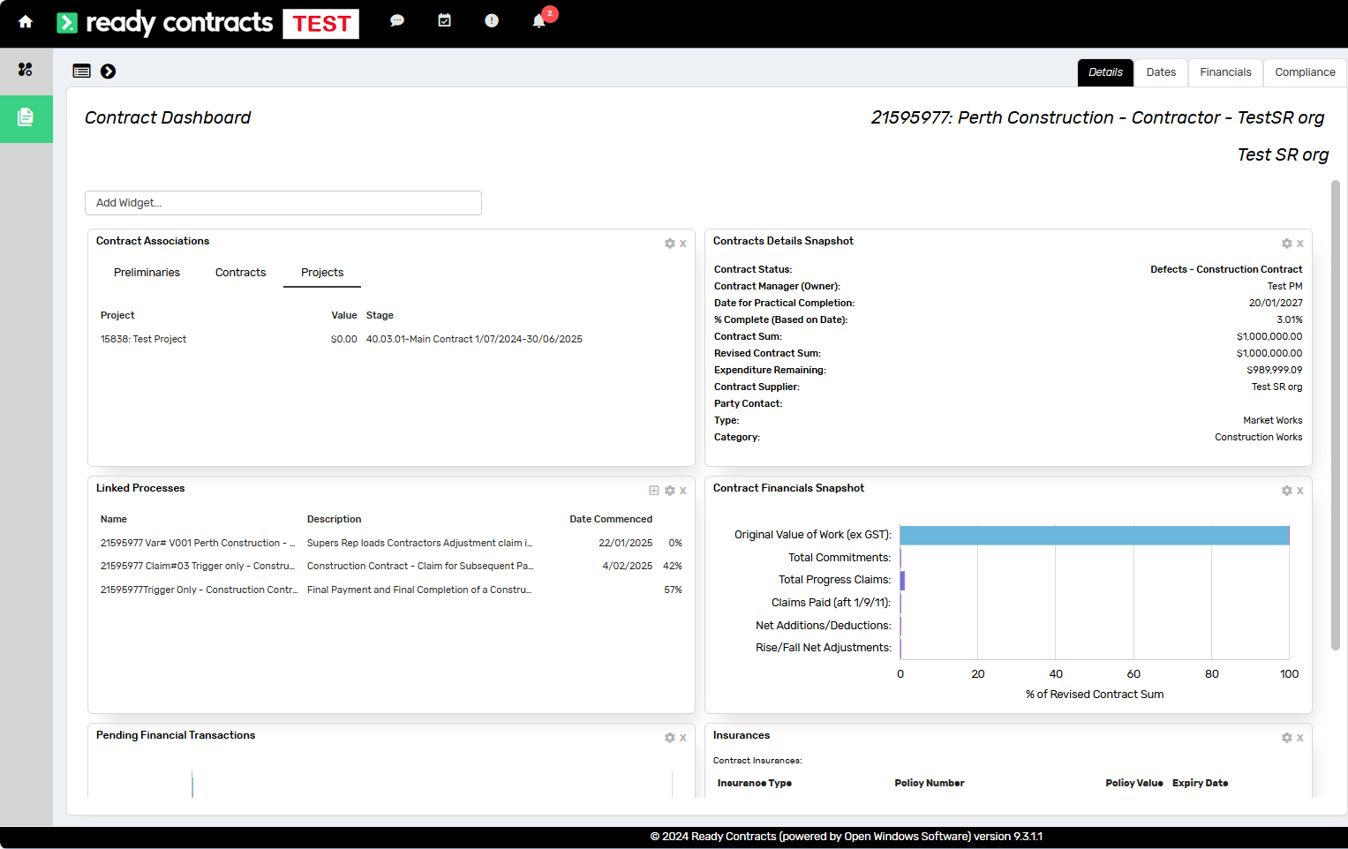

Showing or hiding the Contract List while viewing the Contract Dashboard
The top left corner displays the Contract List and the toggle show/hide icons.
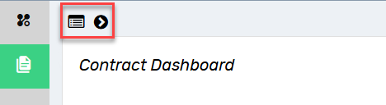
To show the Contract List, click the arrow. The Contract List displays in the left pane.
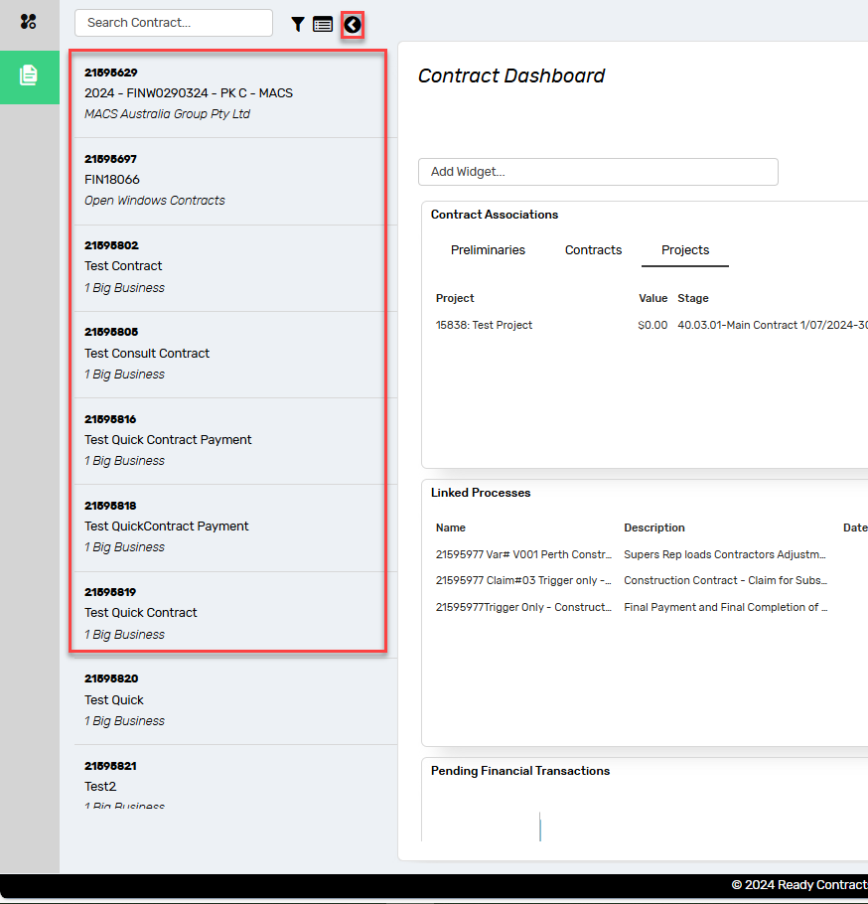
This feature allows you to view the Contract Dashboard of any of the Contracts that you have access to.
You are also able to filter the contract list using the filter icon or display the Contract List view by using the Contract List icon
Hide the Contract List on the left pane by clicking on the toggle arrow again.
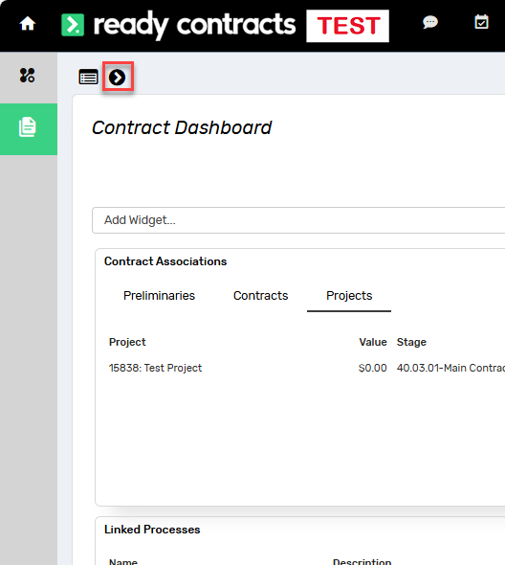

Adding Widgets to your Contract Dashboard
To customise your Contract Dashboard, search in the Add Widget search field.

This will display a list of available widgets that can be added to your dashboard.

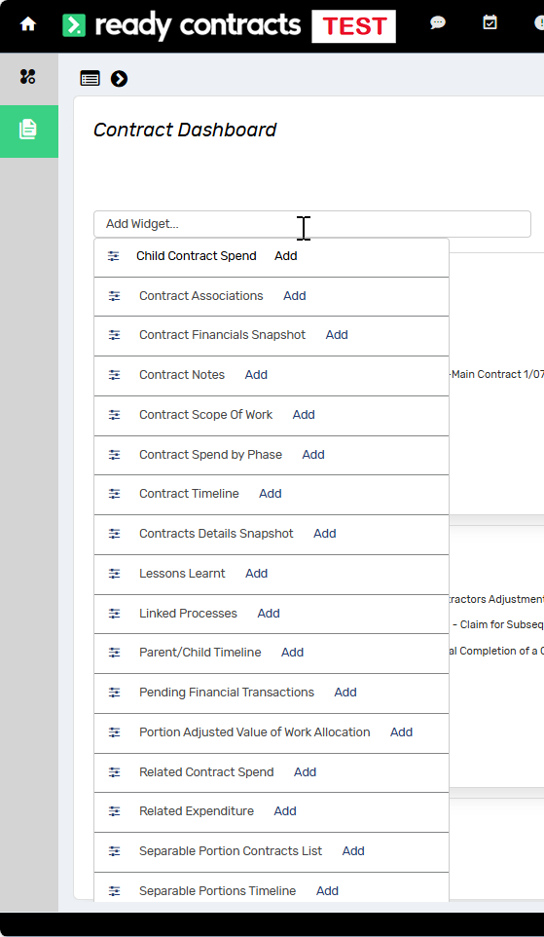

Click Add on the widget you wish to add.

The screen will refresh and the widget will be added to the bottom of the dashboard.

Removing widgets from the Contract Dashboard
Click on the cross icon on the top right of the widget.
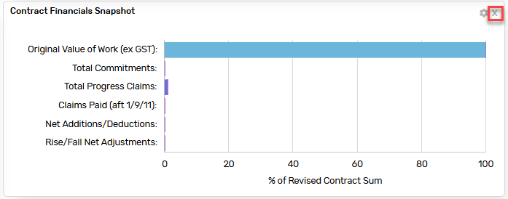

Changing the Widget Settings
If you wish to change the name of the widget for your Contract Dashboard only, click the cog icon and amend the Title, then click Save.
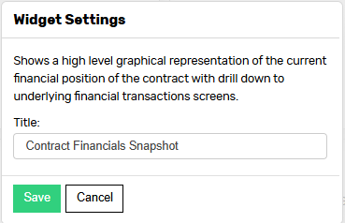

Changing the layout of your Contract Dashboard
Once you have added widgets to your Contract Dashboard, you can customise the layout. Change the position of widgets on the Dashboard by clicking on the title bar, dragging with the mouse, and then dropping it into the new position.

Example of widget location at bottom of dashboard
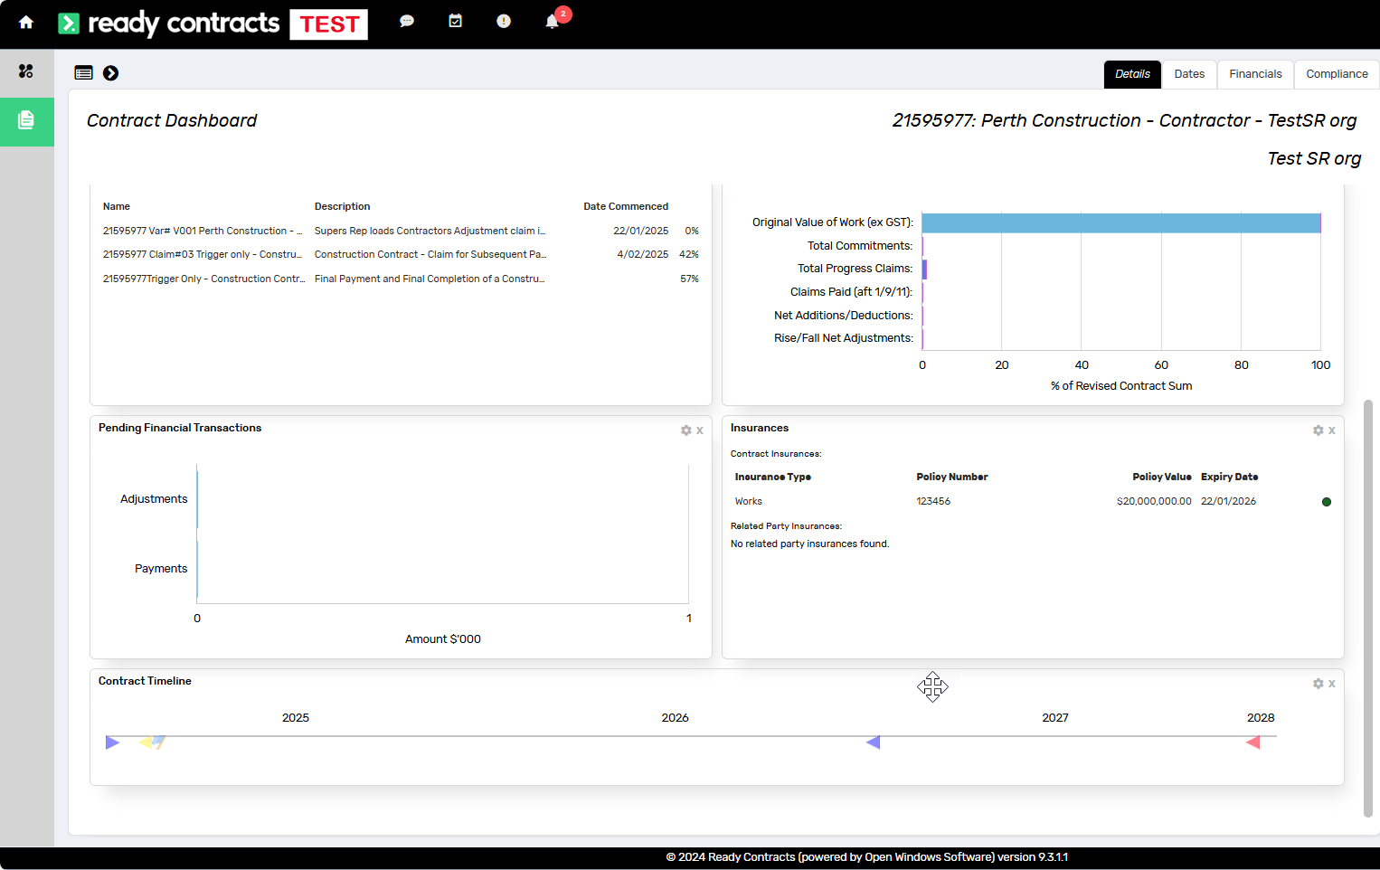

Example of widget relocated to top of dashboard

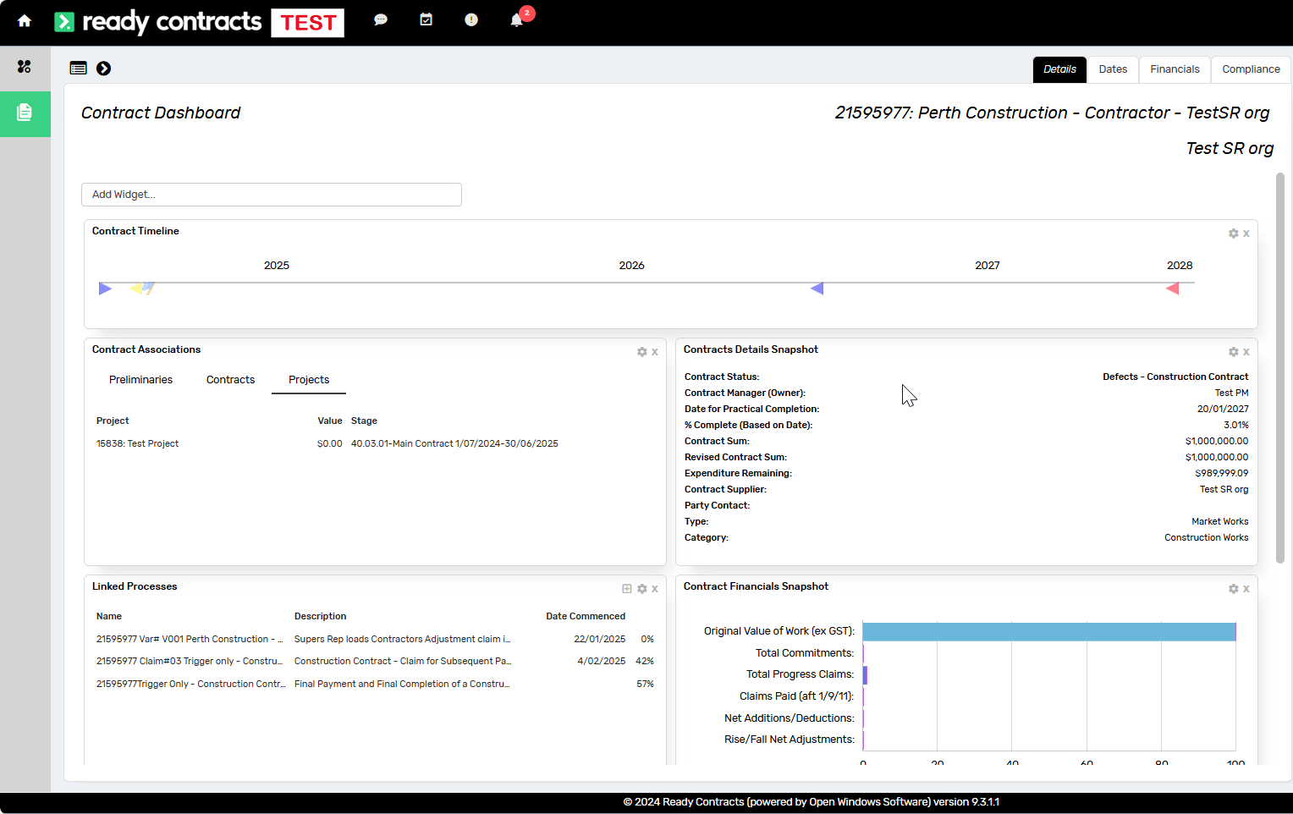

The configuration of the Contract Dashboard will be remembered for your account.

Document control
Approving Authority:  Senior Project Advisor |  | Business Unit:  Building and Contracts
Effective Date |  | Review Date
Replaces QRG | Contract Dashboard
EDRMS File No. |  | Document No & Version | 2.0
Scope | Ready Contracts Contract Dashboard

