Ready Contracts
Construction Contract Practical Completion

This guide provides instructions on the steps required for Practical Completion of a Construction contract as contractually required, including release of retention if applicable.
There are defined tasks for the Super’s Rep and for the Contract Manager and this guide provides instructions for only the Super’s Rep tasks.
Contents
Upload Contractor's Notification of "Anticipated Practical Completion" (within 14 or more days) 1
Review and approve the fully completed As Constructed drawings pack, operational manuals and any other PC Deliverables 2
Complete and Sign As Cons form and submit with drawings/manuals pack to Contract Manager 3
Undertake Practical Completion site inspection 3
Create Practical Completion Certificate 3
Upload Practical Completion Certificate including the list of any outstanding defects 3
Review Financials 3

Locate the process via the Contract Dashboard Linked Processes widget.
The Contract Manager will have completed the first tasks.

Upload Contractor's Notification of "Anticipated Practical Completion" (within 14 or more days)
- Click the plus icon  to upload the document.

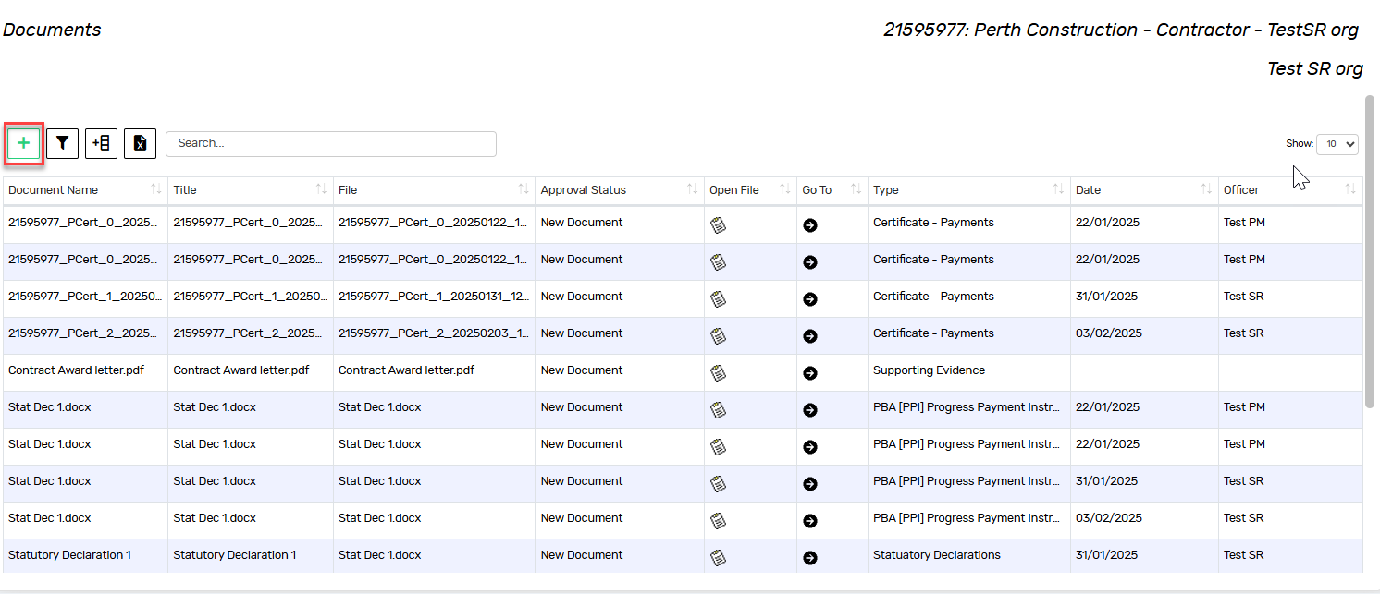
- Add the Contractor’s Notification of Anticipated Practical Completion
- Enter the following details:

- Title
- Document Type
- Date
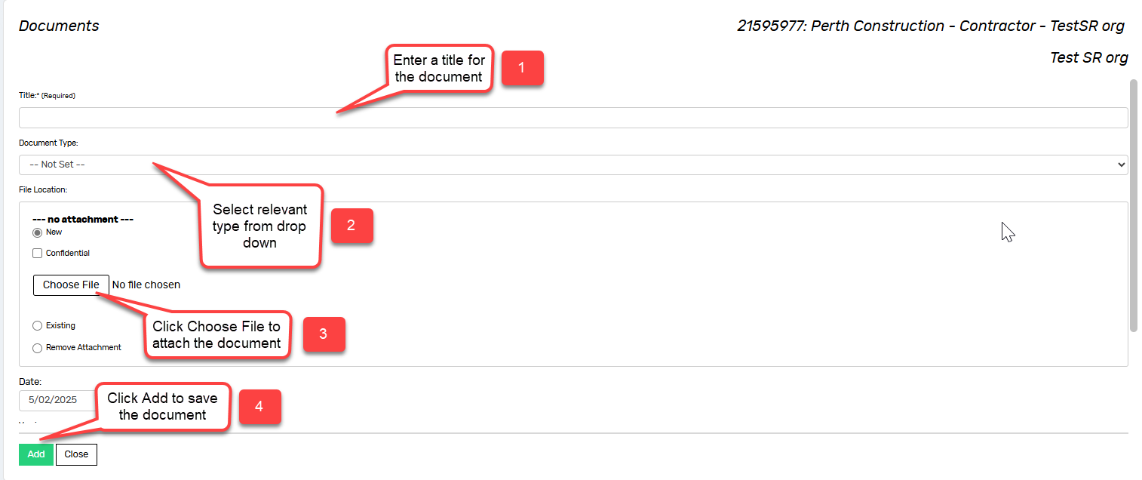
- To attach the document, use the Upload New Document button to locate your document in the relevant folder.

- Click Add to save your document and record it in Ready Contracts.
- Use the  button to progress.

Review and approve the fully completed As Constructed drawings pack, operational manuals and any other PC Deliverables
This is an external task (done outside of the system).
Click Mark Complete when completed

Complete and Sign As Cons form and submit with drawings/manuals pack to Contract Manager
This is an external task. Your Project Manager will provide you with this form to complete.
Click Mark Complete when completed

Undertake Practical Completion site inspection
This is an external task
Click Mark Complete when completed

Create Practical Completion Certificate
- Select the AS2124 Certificate of Practical Completion from the list
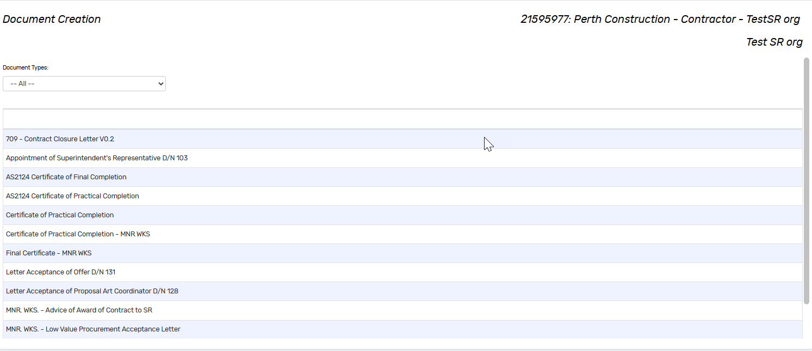
- The template will download to your Downloads folder
- Open the template document, enter any additional information and save the document
- Return to the application and then click
Alternatively, you may create your own compliant certificate.

Upload Practical Completion Certificate including the list of any outstanding defects
- Upload the Practical Completion Certificate using the method described in step 1 of this document
- Click to progress

Review Financials
- Review the financial summary, ensuring that there are no outstanding payments to process
- Click to progress

Marking this task Complete notifies the Contract Manager that you have completed your Practical Completion tasks.

The remaining tasks are for the Contract Manager to complete.

Document control
Approving Authority:  Senior Project Advisor |  | Business Unit:  Building and Contracts
Effective Date |  | Review Date | 20/11/2025
Replaces QRG | Construction Contract - Practical Completion
EDRMS File No. |  | Document No & Version | 2.0
Scope | Ready Contracts Construction Contract Practical Completion process

