Implementing the National Principles for Child Safe Organisations

Case Study: Goodstart Early Learning

Goodstart Early Learning is Australia’s largest provider of early learning and care and Australia’s largest non-government provider of preschool and kindergarten programs.

Our Vision is for Australia’s children to have the best possible start in life.
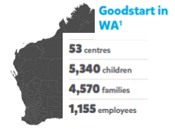
Our Purpose is to ensure children have the learning, development and wellbeing outcomes they need for school and life.
Image 1: Facts on Goodstart centres, employees, children and families in Western Australia.

Project in brief
Goodstart is committed to implementing the National Principles for Child Safe Organisations (National Principles).
There are strong connections and interdependencies between our approach to safeguarding children from abuse, neglect and harm and our strategic goals to deliver exceptional quality early learning and inclusion for everyone:
- World class teaching and learning embeds the rights of children in our daily practice and gives them agency over decisions that affect them. These are foundational preventative principles that are shown to protect children from abuse, neglect and harm.
- Similarly, our strong focus on ensuring all children are included and valued ensures we are always striving to be responsive to the needs of children and families – no matter what their background, experiences or starting point.
Our approach and commitment to safeguarding children from abuse, neglect and harm underpins our daily work with children and families. Our reconciliation journey ensures that we are continuing our cultural learning in a way that supports improved outcomes for Aboriginal and Torres Strait Islander children and families.
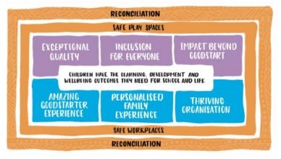
Image 2: Goodstart safeguarding strategy.

Our safeguarding children commitment (National Principle 1)
At Goodstart, we take every action necessary to ensure that all children can feel safe and be safe, and are safeguarded from abuse, neglect, and harm. This means we are committed to keeping all children safe and protected, ensuring they gain a strong sense of wellbeing, optimism and confidence so they have the learning, development and wellbeing outcomes they need for school and life. This is more than just meeting compliance responsibilities.
Underpinned by our Look, Do, Tell Framework, we amplify and promote the voice and rights of children through the prevention, identification and response to child abuse, neglect and harm.

Our Safeguarding Children Framework – how we meet our obligations
Our Safeguarding Children Framework is centred around our focus on prevention, identification and response and builds on our Look, Do, Tell Framework. It was designed with centre teams and experts from across our organisation, as well as external experts, to build a shared understanding about what it means to safeguard children from abuse, neglect and harm. It is underpinned by the National Principles and our regulatory frameworks. It reflects Goodstart’s commitment to ensuring that all children are empowered to feel safe and be safe at Goodstart, in their families and in their community – because we support Goodstarters, volunteers, families, communities and children to ‘Look, Do and Tell’.
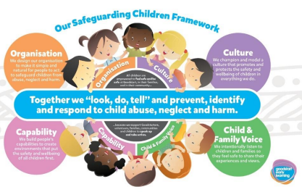
Image 3: Goodstart Safeguarding Framework.

The journey
Safety and ensuring children are safe from abuse, neglect and harm is a strategic priority that underpins everything the organisation does. We know that ensuring children feel safe and are safe is our first most important obligation.

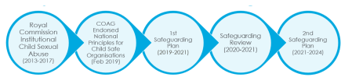
Image 4: Timeline of safeguarding planning.

Safeguarding Children Plan and Priorities
To meet Goodstart’s strategic objectives, Goodstart’s current Safeguarding Plan includes 59 actions (to be completed over four years) to enhance our approach to safeguarding children from abuse, neglect and harm. The actions align with the 10 National Principles which were endorsed by the Council of Australian Governments in February 2019.
Goodstart’s Safeguarding Children initiatives are intended to integrate into Goodstart’s operational processes, rather than be stand-alone activities.
Some of the key highlights include the following initiatives outlined further in this section.

Governance arrangements (National Principle 1)
Goodstart has a designated Safeguarding Children lead and has set up governance arrangements that include a Safety, Health and Wellbeing Board Committee and a Safeguarding Children Steering Committee which have oversight of the delivery of Goodstart’s approach to safeguarding children from abuse, neglect, and harm.
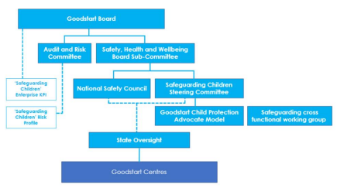
Image 5: Safeguarding governance diagram.

Child Protection Advocate Program
The Goodstart Child Protection Advocate Program focuses on advocacy, promoting awareness of child protection issues and Goodstart’s journey as a child safe organisation.
We have volunteer Child Protection Advocates in all states and territories who play an active role to safeguard children from abuse and neglect.

Self-assessment (National Principle 9)
One of the first steps in the journey to implementing the National Principles was for each Goodstart centre to reflect on their child safe practices and identify priority areas for improvement. The overall results of the self-assessment were used to inform the safeguarding initiatives for the remainder of the plan.
When rating their child safe practices in relation to leadership, culture, governance, policies/procedures, the 53 centres in Western Australia said that ‘all aspects of the action area are evident’ or ‘all aspects of the action area are evident and regularly reviewed’ for the following key action areas:
- 100 per cent: Recruitment, including advertising, referee checks and staff and volunteer pre-employment screening emphasise child safety and wellbeing.
- 98 per cent: Relevant staff and volunteers have current working with children checks or equivalent backgrounds.
- 96 per cent: Leaders champion and model compliance with policies and procedures.
Whilst the self-assessment results were overwhelmingly positive, there were several areas identified for continuous improvement. The highest rating of child safe practices ‘just beginning’ or with ‘some progress’ was in relation to children being offered access to sexual abuse prevention programs and to relevant related information in an age-appropriate way (n=18 centres or 35 per cent). This informed the implementation of the Feel Safe, Be Safe: Protective Strategies Kit outlined further in this document.

Safeguarding Responsibilities for Nominated Supervisors (National Principles 5 and 7)
One of our most important priorities is the safeguarding responsibilities for nominated supervisors. Ensuring we have clarity about roles and responsibilities is critical to meeting our safeguarding obligations to ensure children feel safe and are safe and we are implementing the National Principles and meeting other regulatory obligations.
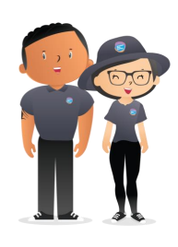
The Safeguarding Responsibilities for Nominated Supervisors program provides a single reference point for centre leaders and includes helpful resources and practice examples. We officially reached 100 per cent completion rate in December 2022. Since then, we have embedded the nominated supervisor responsibilities into our induction program to ensure new Centre Directors are made aware of their responsibilities when they start with Goodstart.
Image 6: A cartoon of Goodstart employees.

Our Safety Commitment
Safety wraps around everything that we do at Goodstart.
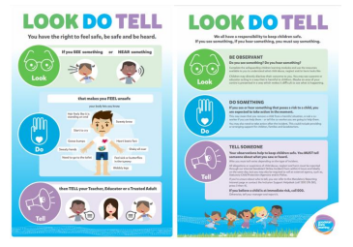
When we talk about safety, we mean all safety, including safeguarding children from neglect, abuse, and harm. It’s not just about being safe – it’s about feeling safe from a cultural and psychological point of view as well.
Our Safety Commitment imagery is an important symbol of our commitment to protecting all Goodstarters and children from harm, as well as our connection to the communities in which we work. Our commitment is a personal choice that is made on a daily basis by each and every Goodstarter.

Code of Conduct and Child Safe Behaviour Standards (National Principles 1 and 10)
Our Code of Conduct and Child Safe Behaviour Standards make clear our expectations of all Goodstarters. They apply to anyone representing Goodstart - including centre and centre support office team members, board members, students, volunteers and contractors.
Image 7: Fact sheet explaining the Look, Do, Tell approach to safety.
The Goodstart Code of Conduct helps each of us to align our behaviour with our Guiding Principles, our Foundations, our Safety Commitment and our Child Safe Behaviour Standards, as well as our policies and procedures so we can make the right decisions every day.

Look, Do, Tell Framework (National Principles 6 and 8)
A child safe culture is championed and modelled right across our organisation – so if any of us see something that doesn’t feel right, we must ensure people feel safe and empowered to speak up. We all have a responsibility to look, do and tell to prevent, identify and respond to child abuse neglect and harm.
Our Mandatory Safeguarding Children Learning Plans and resource library support the implementation of our Look, Do, Tell Framework.
- Look – by providing a child safe environment and effectively identify signs and indicators of abuse, neglect and harm.
- Do – by taking action in the moment to make sure that all children are safeguarded from abuse, neglect and harm.
- Tell - by upholding our reporting obligations and knowing what to do if you feel, see or hear something that isn’t right.

Child safe recruitment (National Principle 5)
Child safe recruitment practices, including candidate screening processes, are foundational to Goodstart being a child safe organisation. Our child safe recruitment processes ensure that the people working in our centres with children are suitable and supported to reflect child safety and wellbeing values in practice. This means:
- We emphasise our commitment to child safety and wellbeing when advertising for, recruiting and screening staff and volunteers.
- Our position descriptions, selection criteria, interview questions and referee checks demonstrate we are a child safe organisation.
- Goodstart has engaged the Australian Childhood Foundation to deliver child safe recruitment training to ensure Goodstarters:
- understand why robust child safe recruitment processes are necessary
- learn how to maximise child safe steps in the application process
- learn how to ask the right interview questions and interpret and manage warning signs and behavioural based cues
- build confidence in conducting quality reference checking and exploring red flags
- understand their obligations with outsourcing recruitment and screening practices.

Safeguarding Children Mandatory Training
Our foundational learning for all Goodstarters is called ‘Safeguarding Children: Together we prevent, identify, and respond to child abuse, neglect and harm’ and consists of six modules covering five topics:
- First steps
- Being a Child Safe Organisation
- Empowerment, Participation and Cultural Safety
- Implementing Safeguarding Children Requirements
- Recognising Indicators of Child Abuse, Neglect and Harm
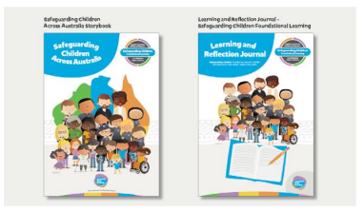
- Responding to Child Abuse, Neglect and Harm and Supporting Those Who Disclose Harm.
Image 8: Goodstart safegaurding storybooks.
The modules are enhanced by supplementary materials such as a storybook, learning and reflection journal and an extensive resource library on each topic including staff meeting activity packs and information sheets. Staff members engage in a learning needs self-assessment to create a personalised learning plan utilising these additional resources to enhance their knowledge and capabilities.
Over 3,000 Goodstarters completed the safeguarding foundational learning plan within the first six weeks following implementation, and the learning evaluation scores were overwhelmingly positive:
- “I feel confident about applying what I’ve learnt in Safegaurding Children Foundational Learning back on the job.”
- “I am committed to applying what I’ve learned from Safeguarding Children Foundational Learning in my work.”
Goodstarters have said that the training:
- “Gave me the confidence to take action if I notice something not right with a child; also, to listen to children and let their voice be heard and believed.”
Image 9: Cartoon of a Goodstart educator and children.
- “Being attuned and actively engaged with children to notice any changes in their mood, behaviour, or body language that might indicate their emotional and physical state.”

Feel Safe, Be Safe: Protective Strategies Kit (National Principle 2)
As educators, we play a vital role in teaching children age and developmentally appropriate protective strategies in collaboration with families.
Our Feel Safe, Be Safe: Protective Strategies Kit enables teachers and educators to leverage everyday teaching and learning opportunities, reinforcing protective strategy concepts through relationships, discussions, routines, rituals and transitions, and group experiences, in response to children’s play and learning.
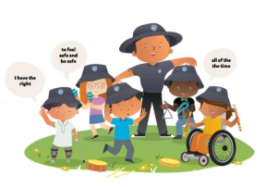
When these age-appropriate strategies are taught to young children, they are equipped with the skills to recognise and respond to potentially unsafe situations (including online); understand their bodies, emotions and early warning signs; set boundaries; and persist in seeking help from a trusted adult.
Image 10: The Feel Safe, Be Safe: Protective Strategies Kit.

The Feel Safe, Be Safe: Protective Strategies Kit includes a:
- Guide – details teaching strategies and learning experiences to embed protective strategies in everyday practice for children aged birth to five.
- Resource kit – tools and resources to support teaching and practice.
- Practice videos – examples of protective strategies in action.

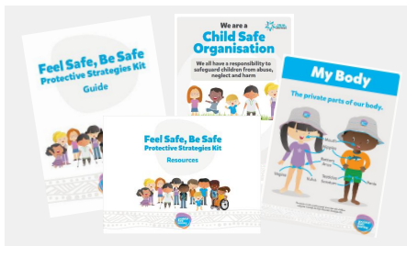
Child focussed complaints and concerns processes (National Principles 4 and 6)
Goodstart has robust processes for responding to complaints, concerns and disclosures of child abuse, neglect and harm. Children are included in the investigation process (unless there is a good reason why this should not occur), showing the child their voice is valued, and they will be listened to. This supports their empowerment, participation, wellbeing and safety. A Safeguarding Children Panel has been established to ensure an immediate, appropriate, and consistent response to allegations of child abuse, neglect and harm. The Panel makes recommendations on the organisation’s response, including in relation to risk management strategies, whether a formal investigation is warranted, and if so, the investigation findings and outcome.

Next steps

Safeguarding (National Principle 9)
Our safeguarding approach is continuously reviewed, evaluated and improved through the regular analysis of incident and complaint data, feedback about child safe practices and challenges that arise. This includes updating the Safeguarding Children Plan, and the sharing of good practice and learnings on a regular basis.
The implementation of the National Principles is reviewed every two years to improve child safe practices and inform priority areas for improvement. In 2024, Goodstart will undertake an organisational self-assessment, and each Goodstart centre will reflect on their child safe practices to inform the development of the 2025-2028 Safeguarding Plan.

Stakeholder consultation for child safe practices (National Principles 3 and 10)
The next round of stakeholder consultation is scheduled for the first half of 2024. This informs the review and development of our child-safe policies and procedures and provides families and communities with a say in the organisation’s policies and practices. It also informs them about the organisation’s operations and governance.
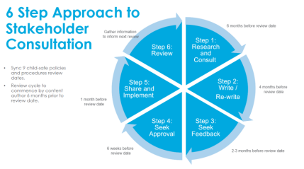
Goodstart adopts a 6-step approach to stakeholder consultation which is outlined in the following image.
Image 11: Goodstart child safe policy cycle graphic.

Sharing the learning

Community of Practice (National Principle 3)
Image 12: Photo of Goodstart employees.
We welcome any early childhood safeguarding professionals to join our informal online community of practice where we share best practices and reflect on safeguarding topics and emerging themes in the implementation of the National Principles.
Please email safeguarding@goodstart.org.au.

Child Protection Week
During Child Protection Week, Goodstart engages in a nation-wide communications and awareness campaign to promote awareness about child protection issues and a child safe culture.
In 2023, our centres were invited to share the voices of children through artwork (in any format) with the key theme ‘I have the right to feel safe and be safe all of the time’.

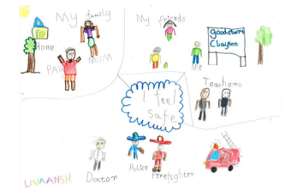
Child Safe Organisation Award
Image 13: A child's drawing of feeling safe.
Goodstart was the recipient of the ‘Child Safe Organisation’ award at the esteemed Queensland Child Protection Week awards in 2023.
This award recognises Goodstart’s unwavering dedication to being a child safe organisation and the implementation of the National Principles.

Safeguarding children advocacy (National Principle 1)
Goodstart continues to take up opportunities to consult and provide feedback to government regarding the implementation of schemes and frameworks to support the protection of Australia’s children, including Reportable Conduct.

Last updated: 26.02.2024

