

Commissioning Toolkit for Community Services
Tool 6: Modify and Enhance

These Commissioning Capability Tools have been developed by the Western Australian Department of Finance, in partnership with Rebbeck.
Rebbeck is a boutique strategy consultancy and commissioning support organisation that specialises in commissioning capability development. Rebbeck works with healthcare and public services organisations across Australia to support commissioning with a focus on reshaping services to achieve sustainable outcomes for the people of Australia. Find out more at www.rebbeck.com

Modify and Enhance: At a glance

1. Overview
Modify and Enhance encompasses a group of targeted activities that work alongside or as an alternative to procurement with the aim of improving commissioning performance.
2. Purpose
This tool enables us to identify how best to address needs identified in earlier tools and highlights alternative change levers we can use. This tool also includes decommissioning as a natural part of the commissioning process.
3. Workflow

Identify and assess options to modify and enhance
1

Design and execute activities
2a
Decommission services
2b
4. Output
On completing the Modify and Enhance tool, we will have assessed the various approaches that can be used to improve commissioning performance and how we can incorporate co-design methods and cultural safety into the process.
5. Tools and resources
Nil

1. Overview

1.1 What is modifying and enhancing?
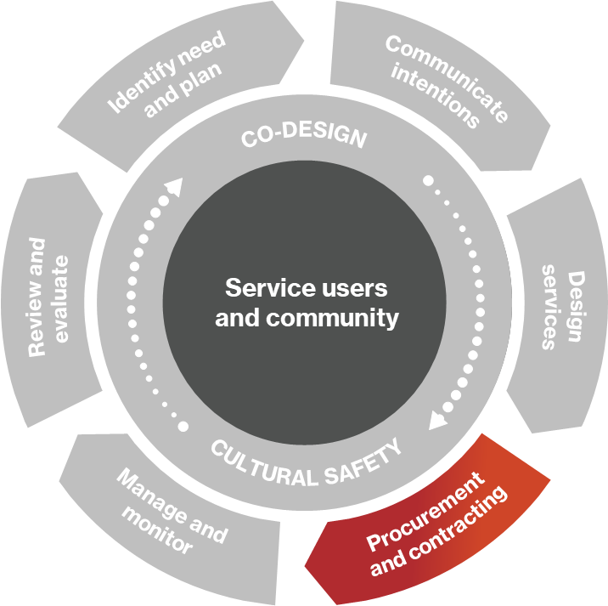
Modify and Enhance sits alongside Procurement and Contracting as a complementary commissioning phase.
Procurement is not the only option available to commissioners to introduce changes in service provision. Commissioners can also change existing services to meet the identified needs. This includes making changes to services operated by the department or how external service providers operate internally and with each other. The modifications or enhancements to existing services can be done instead of procurement or as a complementary activity.
Figure 1: Commissioning cycle
This tool allows commissioners to identify, agree, design, and execute well-targeted service modifications to address identified priorities and leverage opportunities to enhance service performance. The modification and enhancement activities can include strategic partnerships, market-shaping initiatives, workforce development, technology enablement, infrastructure enhancements, or in-house service provision.

1.2 Commissioning levers
Procurement is discussed in detail during the Procurement and Contracting tool, and while an effective method for driving change, there are other change levers we should also consider. These include:
- market management
- funding
- system leadership
- clinical engagement
- community engagement
- service provider collaboration.
This tool discusses how commissioners can use these non-procurement commissioning levers.
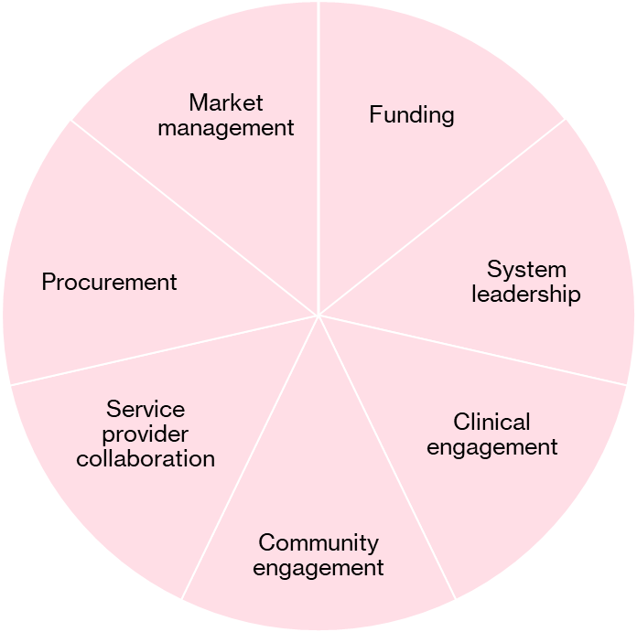
Figure 2. Commissioning change levers

2. Purpose

2.1 Why do we conduct modifying and enhancing?
This tool can be used in conjunction with the Procurement and Contracting tool to assist commissioners to identify the set of activities to address prioritised needs. It draws on the ideas and insights of the Design Services tool and points to how commissioners and their strategic partners can work to modify and enhance services and service provision, namely:
- service provider market engagement (supply side external procurement or market shaping)
- workforce development
- service user demand management
- operating model development, including funding arrangements
- physical infrastructure
- digital and technology infrastructure
- culture
- policy and advocacy
- regulation.
Consider what other systemwide benefits can be pursued to enhance the overall functioning of the public services system as part of the commissioning initiative.

3. Identify and assess options to modify and enhance

3.1 Identify and assess enabling options
Government departments broadly have three options for deploying services to meet identified needs They can do it themselves (Provide), they can work with others (Partner), or they can outsource to a third party (Procure). For significant change (whole system improvement), a combination of these options may be required for different aspects of delivery. This is illustrated in Figure 3.
The first step in Modify and Enhance is identifying and assessing the options, or combination of options, to meet the priority needs.
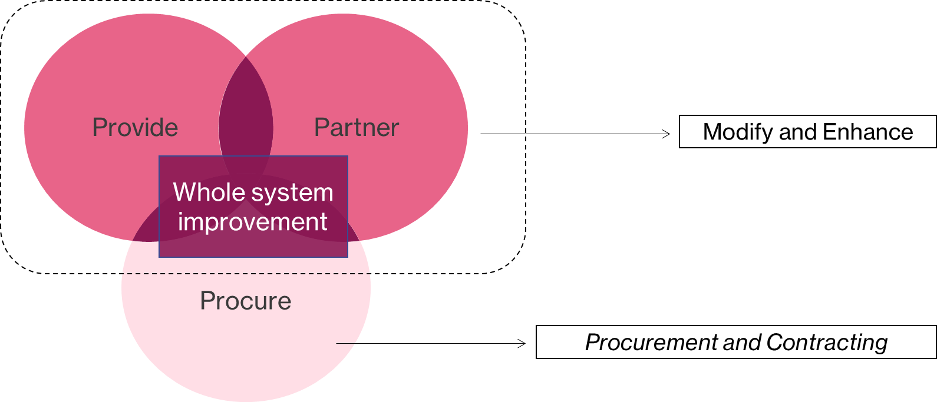
Figure 3. Options for delivering services and system improvement.
- Procure: Purchasing goods or services from service providers in the market (see Procurement and Contracting tool).
- Partner: Collaborating with strategic service providers to influence and improve the system.
- Provide: Delivering services in-house by Western Australian government agencies.
Note: The Procure option should be considered alongside Provide and Partner. However, as Procurement is discussed in detail in the Procurement and Contracting tool, this tool will focus on the Provide and Partner options.
Options need to be assessed objectively to ensure that they are feasible. Regional variation is also a factor, so options that work in one area may not translate to other locations. A series of feasibility tests may be needed to assess the possibilities identified, as outlined in Figure 4.
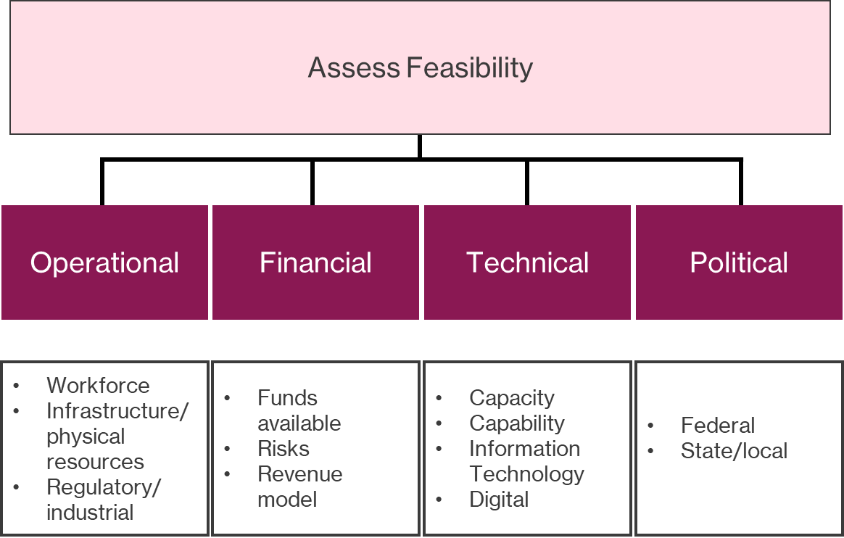
Figure 4. Feasibility tests.
If options pass the feasibility tests, consider each option’s impact against the ease of implementation as a means of rating the available options.

3.2 Consider market shaping activities
What is market shaping?
Market shaping is a process of understanding and collaborating with existing and potential suppliers and choosing the right shaping strategies to deliver desired change, and may include:
- facilitating new entrants
- encouraging service providers to collaborate and perhaps merge
- testing the market to ensure readiness/appetite/capacity to tender
- training service providers to improve their tender writing abilities
- workforce development, e.g., engaging with universities to support student placements
- workforce recruitment.
Why do we do it?
By shaping the market, commissioners attempt to balance supply and demand. A balanced market enables commissioners to achieve a successful procurement where the right services are obtained at the right quality and price.

Market shaping activities, when used selectively, can:
- enhance competition to improve value for funders and service users
- develop service provision for hard-to-serve groups
- reduce duplication through market segmentation
- resolve unwarranted variation in services and incentivise quality
- encourage innovation
- encourage service integration
- ensure the market has the capacity and capability to respond to a request
- build service capacity to meet anticipated demand growth.
The number of service providers in some rural and remote locations is so few that market principles may not apply. In these circumstances, partnering to sustain services is the overriding priority.

3.3 Identify potential partners
Partnering is a commonly used approach for achieving system-level improvements.
In the Design Services tool, we examined how commissioners should engage strategic partners to enact system-wide change. Strategic partners will often be commissioners and we should be aware of co-commissioning opportunities. Co-commissioning sees partnerships between entities with similar objectives and prioritises pooling funding, influence, and resources to jointly commission services. This will usually require one of the partners to assume fund holding and serve as the lead for contract performance management. Co-commissioning represents a high level of maturity in relationships between partners and helps deliver the best value to the communities.
Commissioners also play a significant role in sponsoring collaboration between service providers. Collaboration across service providers is vital when the commissioning activity seeks to improve the continuity of services across multiple service settings. Collaboration options between entities may be viewed as a spectrum, as outlined in Figure 5. It is essential to remember that other commissioners may not have funding to contribute to an initiative but can support it through in-house arrangements or by offering constructive influence to enable change.
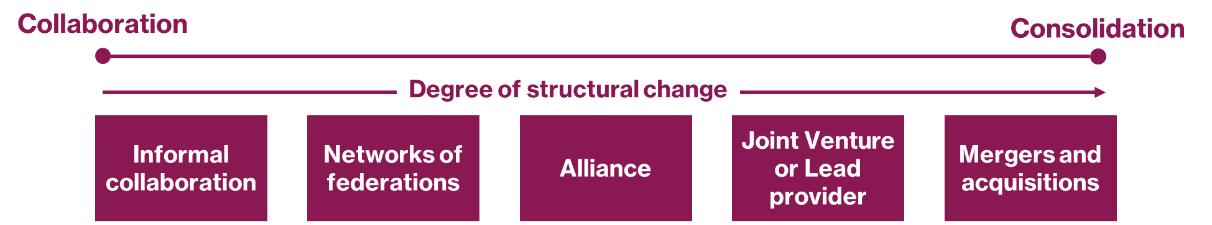
Figure 5. Spectrum of structural change involved in different types of collaboration.
Commissioners should be explicit about the nature of the partnership, which should reflect the overall strategic intent. Some partnerships will be focused on specific programs to meet the needs of a discrete group, while others will constitute long-term overarching alliances to deliver whole-of-system change. Figure 6 illustrates a range of ‘vehicles’ that can define and shape the nature of partnerships depending on the formality required.
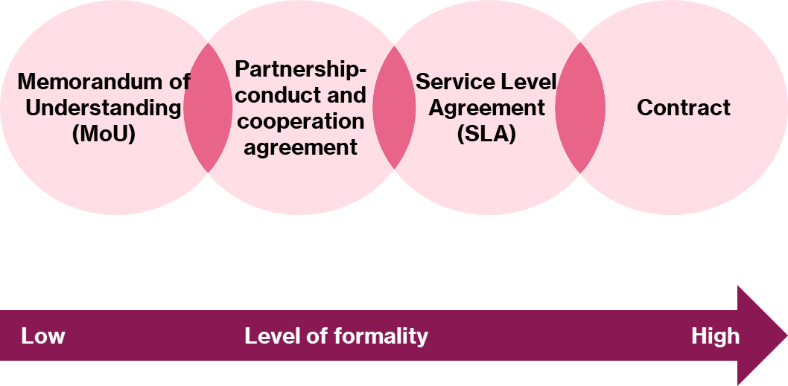
Figure 6. The level of formality varies with different partnership vehicles.

4. Design and execute activities

4.1 Plan for implementation
Planning needs to consider the mix of selected activities to be pursued as part of the commissioning initiative: procurement, partnering or in-house provision.
These considerations will assist with various decisions in the Procurement and Contracting tool, including how external procurement will fit in with the partnering activities and any in-house provision.

Partnering decisions to be made at this time include:
- What is the potential for co-commissioning?
- What role should each partner have in delivering the service model design?
- What is the right partnership vehicle (e.g., memorandum of understanding or service level agreement)?
- What is the right partnership governance arrangement, including conflict resolution?
- What should be the extent and nature of internal partnerships?
In-house provision decisions to be considered include:
- What should be the extent of in-house provision?
- What would be the rationale and justification for in-house provision?
- How can the outputs of the design services phase be used to inform the design of the internal service?
- What should the interfaces be with any external services procured as part of the initiative?
- What should the internal interfaces be with associated in-house services?
Like external procurement, a service specification is also required for in-house provision, which addresses the strategic intent and objectives, service philosophy, service scope, service model, target group and eligibility, target catchment, and service interfaces.

4.2 Consider risks and mitigation
When we implement change through co-commissioning or provide services in-house or through procurement, there are several risks involved and steps we can take to mitigate those risks.
- Relationships may be tested: Commissioners will find that strategic partnerships and personal relationships might be tested so conflict resolution protocols are advisable.
- Political influence: There may be political factors to consider and ministers should be kept updated and informed of the timings of announcements.
- Decommissioning: Consider the direct and indirect consequences of decommissioning for service providers and users.
- Industrial implications: The effects of industrial action need to be considered and managed sensitively.
- Media management: Assess the likelihood of interest from the media and plan accordingly.

5. Decommission services

5.1 Confirm rationale for decommissioning
Decommissioning is the process of ceasing service delivery from a service provider and is part of our suite of options to modify and enhance the service provision landscape. It may include some or all the services provided by a service provider. To decommission a service, we need to confirm the reasons why the service is no longer required or viable. Key reasons include:
- state or commonwealth cease to fund a service
- shifting needs or priorities within a Western Australian community
- service provider performance failure
- service provider withdraws from a contract.

5.2 Develop decommissioning project plan
When creating a decommissioning project plan, thorough analysis and evidence will have been collected to justify the decommissioning process. The project plan needs to outline our approach and the scope of the decommissioning process. Key stakeholders need to be identified and briefed on the expectations of the decommissioning project and the required activities. Within the plan, agreements should be made regarding deliverables, project governance structures and timeframes.
Decommissioning projects can carry significant risks and thorough risk identification and mitigation should be undertaken. Each risk identified should have an individual, detailed description and steps that the organisation can take to mitigate those risks. The project plan should include a timeline and highlight key deliverables, meetings, and milestones.

5.3 Understanding the rationale and impact of decommissioning
Before decommissioning, we should re-evaluate the justification for the decision and consider factors such as adjusting the service provider costs or allocation of benefits. We should have discussions with our service providers and system partners to fully understand the impact and risks of a decommissioning event and incorporate their views into our decommissioning planning, while being careful not to disclose market-sensitive information.
The types of risks and impacts that may emerge from discussions with service providers and partners include:
- The destabilisation of other services due to financial and operational impacts on the service provider’s total business.
- The impact on service users no longer able to access services from the service provider (this may include the service being decommissioned as well as other services provided by the service provider that have been impacted).
- Changes to staff numbers or roles, we may need to consider how staff can be transferred. Staff may become aware of plans to decommission a service, which may lead them to seek employment elsewhere, so it is essential to have strategies in place to retain staff.
It is also critical to involve service users and experts in developing and managing a transition plan to ensure the safe management of service user needs.

5.4 Principles for decommissioning
Successful decommissioning should be underpinned by the following principles. Decommissioning should:
- Be strategy led and have a vision for the whole system. The plan should explain how the decommissioning process will support the broader vision.
- Engage and involve experts in the discussion as their support will be crucial.
- Engage the local community and service users in planning and ensure that the service is designed with them in mind.
- Involve service providers in proposals early and seek to understand the impact of decommissioning on the relevant service providers.
- Be evidence-based so that we can justify the reasoning behind our decision.
- Be equitable and ensure that no sector is given an unfair advantage during the process.
- Have a clear audit trail of all critical decisions.
- Carry out an impact assessment to identify the anticipated or actual impact of the change to services.
- Follow a reasonable timeframe.

6. Considerations for co-design and cultural safety

6.1 Co-design to understand partnering approaches
Co-design is the process of involving and creating services or products with the individuals and communities that will use or deliver them. By collaborating with system partners, it will enable us to:
- Understand the responsibilities and cultures of other sectors and partner agencies.
- Build credibility with system partners, including Aboriginal Community Controlled Organisations, non-government organisations, universities, local government, state government and social services.
- Facilitate partnerships and integration of services.
- Engage system partners to increase the use of co-commissioning.
- Take responsibility for contentious decisions instead of avoiding them.
- Co-design the whole system rather than just the part of the system that we fund.

6.2 Market-shaping to assist disadvantaged service providers
As commissioners, we have our own insights into the market and the services we want to commission. However, the market may not be ready to respond to our needs. Therefore, we need to use market-shaping skills to promote fairness within the market. This may involve a series of activities to help disadvantaged service providers.
Partnerships, alliances, or mergers may increase the ability of individual service providers to respond to our needs. We may consider disaggregating tenders or contracts to assist smaller service providers. We can also consider removing restrictions or provide training if disadvantaged service providers face barriers to responding to our requirements.

7. Communicating intentions

7.1 Communicate intentions to key stakeholders, including communities
We must communicate our intentions with key stakeholders concerning our plans to Partner and Provide. It is especially important to communicate our intentions to decommission services. Communities will expect significant positive change to be the result of our partnerships. Therefore, we should be clear about what we intend to achieve through the partnership.
Decommissioning can often be seen as a loss to service users and community members. It is important that commissioners develop robust messaging and thoroughly develop their stakeholder engagement strategy for decommissioning projects (see Planning tool). Messaging should explain, in simple terms, the rationale and how communities will have better services as a result of the change.
There are many channels for communication with key stakeholders and the community more broadly, which include:
- community briefings
- sector briefings
- sector peak announcements
- tender briefings
- registered stakeholder newsletters/updates
- website updates
- media releases
- featured articles in industry journals.

8. Links to resources
Nil

